**4. Infix to Postfix with Evaluation**

Linked List Implementation of Stack is used to convert the given infix expression into postfix for evaluation.

* Three main functions are defined that help in the overall conversion.
* The stack only holds one character at a time.
* **Push()**: is used to push the elements encountered in the infix expression
* **Pop()**: is used to pop out the elements freom the stack as and when required by the program.
* **characterPriority():** is used to understand the precedence of the operator while pushing or popping out the element from the stack during the conversion.
* **Postfixcalculator():** is used to evaluate the converted postfix expression as a character array and calculates the expression, thereafter returning the final result.
* The program supports the use of multiple digits for a number as demanded by the question
* The postfixcalculator function uses it’s own push and pop operations that are done on a different integer stack to get the final result.

**Execution Screenshots:**  
  
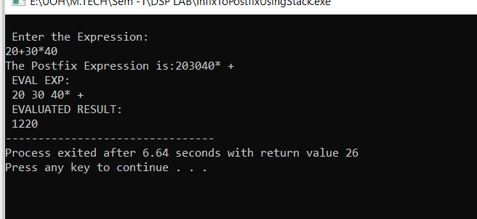

**Debug Screenshots:  
